The Surrender at Appomattox Courthouse

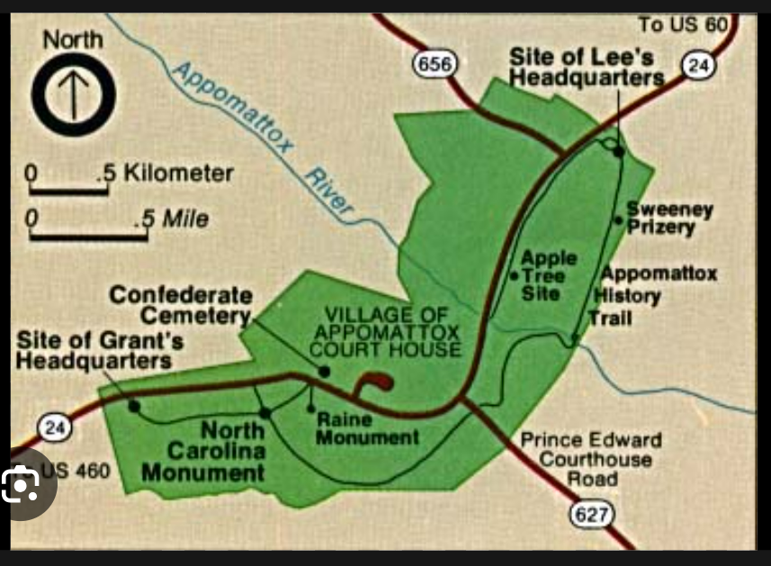

The Surrender at Appomattox Courthouse occurred in April 1865 during the American Civil War. Confederate General Robert E. Lee, thought that the Confederate would lose since the Union had way more resources and they were well prepared for a war so he gave up to the Union General Ulysses S. Grant at Appomattox Courthouse. This surrender signaled the end of the Civil War. General Grant was kind enough to not betray General Ulysses and the confederate soldiers, letting them keep their horses and providing them with food. This event was a major event because it signaled the Northern states and the Southern states would reunite.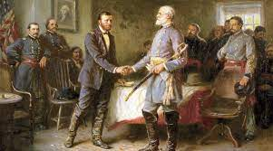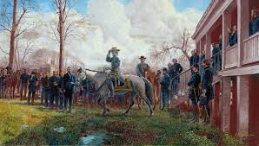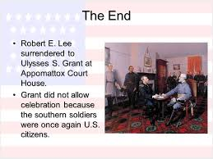

Abraham Lincoln

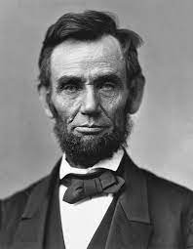

Abraham Lincoln was a major reason for the surrender at Appomattox Courthouse but he sadly was also assassinated for that reason. Since John Wilkes Booth, from the Confederate thought that there was a chance the Confederate could still win even after the surrender. He thought that if they assassinate the people who are in higher ranks of the Union then the whole Union would collapse and the Confederate would win. But only Lincoln’s assassination was done since the others failed.

Wilmer McLean

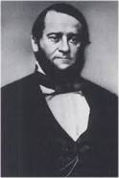

Even though he wasn’t physically in the Civil war, he is still related to it. Wilmer McLean lived in Manassas, Virginia and the 1st major battle that marked the beginning of the Civil war occurred in his property. After the battle, he moved into Central Virginia and COINCIDENTALLY the end of the Civil war also happened inside his house because he likely had the best house in Virginia where the end of the war was decided to happen. Now even though he tried to not be connected to the Civil war, at the end he became very connected to it.

Robert E. Lee

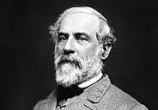

Robert E. Lee, commonly known as the general of the confederate, played a huge role in the Civil War. He is known for his skills of taking the right decision and his leadership. Lee most likely made the most major decision of the whole Civil War that changed everything. In April 9th, 1865 Lee surrendered to the General of the Union known as General Grant due to extreme circumstances, saving many lives from the war that could have been even more deadly. Even though some people think that he was a coward, he had made the right decision because the Confederate was already likely to lose due to lack of resources and support.

Connection To Texas History

The Surrender at Appomattox Courthouse holds importance in Texas history as it shows the conclusion of the American Civil War, a conflict in which Texas played a crucial role. While the event occurred in Virginia, it deeply effects Texas since the state was part of the Confederate states that decided to go against the Union. This moment resulted changes in Texas, leading to the state to change its relationship with the Union. This simple event even caused changes in rules of Texas. The surrender not only marked the end of the conflict but also helped for Texas to join into the United States.

This event connects with Texas History because it has shaped Texas. If The Surrender at Appomattox Courthouse never happened, then Texas would have had to face aggressive force from the Union since it was way more powerful than the Confederate and definitely had a chance to win through violence. Texas could also still be part of the Confederate if some other country/countries decided to step in and help the Confederate. But even if the Confederate was still there it is likely to not have slavery since most countries would then not help it.